1. 
2. **Agenda**
   1. What is an API?
3. Graphical user interface, text, application, email

   Description automatically generated
   1. **API**:
      1. A messenger which takes msg from you to some other app and fetches the response from the app to you.
   2. **Technical Messenger**:
      1. As it is not a human being that could add some gossip to the msg from one company to another company.
   3. **Why do companies use API**?
      1. Because it has emerged as one of the most distribution channels.
      2. **Cross Sell**:  
         From your web site, you sell A product but you realize that A also needs X Product as well but you don’t can’t deliver X Product.  
         So, you get in touch with a company which provides X Product.  
         Now, you sell A product along with X product.
      3. **Innovation**:  
         API also helps in innovation.  
         Big companies like Google, Facebook, they share their APIs with developers and what Developers do, they taking all these APIs create a new API a 3rd new product which even those big companies couldn’t imagine or think and these Developers with their own creativity, they create a new product.  
         So, API helps to create innovation in the market like financial sector etc.
      4. **Quick to Market**:  
         API also helps a product go to market very fast.  
         Distribution is not an easy task.  
         You have to try with different Distributors, Retailers, Warehouses, people and you have to do a lot of marketing.  
         So instead of doing everything by yourselves, you just identify a local level player and say that I don’t have reach there.   
         One of the Distributors introduces my service there and you earn the profit and shares a little to the Distributor.   
         The benefit to the Distributor is that it doesn’t have to create the product and no need to get into the regulation process of a bank.
   4. APIs are not used only in financial services but also in other fields like 🡪 Travel, Food, Clothing etc.

Different Kinds of APIs.

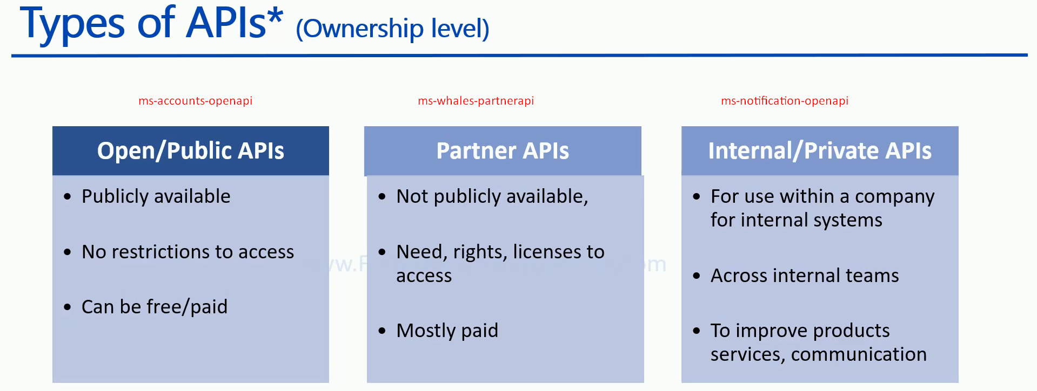

1. **Open/Public APIs**:
   1. Such kinds of APIs are publicly available.
   2. Developers can just plug into their system and start working.
   3. Such APIs are available for free of cost because of different benefits you get like innovation, Distribution.  
      But some time companies may charge a small fee.
2. **Partner APIs**:
   1. Not publicly available.
   2. We create such kinds of APIs for a particular customer or for a particular Distribution Channel.
   3. There are some agreements regarding what the Distribution Channel can do and can’t do.
   4. Companies also give some kind of license and companies also share some revenues with the Distribution Channels.
   5. So, Partner APIs are mostly paid and not free unless those companies have their own Distribution Channels or marketing strategy where they think that giving free to a partner can add more value than charging money from them.
3. **Internal/Private APIs**
   1. Mostly these are not for Business purposes but for internal purposes.
   2. For example: A company can use different APIs of different departments to create a Dashboard where a CEO can see what is happening in different departments.
   3. They can also be used to create internal communication systems where different department APIs are plugged in.

I am not talking about APIs at technical levels like REST APIs, standalone APIs.  
This is about only non-technical.

